

Mini Project Report

of

Internet Technologies Lab (CSE 3262)

Book Store Management

SUBMITTED

BY

|  |  |  |  |
| --- | --- | --- | --- |
| NAME | REGISTRATION NUMBER | ROLL NUMBER | SECTION |
| Shyam Sundar Bharathi S | 200905302 | 53 | B |
| Ajay Rajendra Kumar | 200905390 | 61 | B |

Department of Computer Science and Engineering

**Manipal Institute of Technology, Manipal**

**April 2023**



DEPARTMENT OF COMPUTER SCIENCE & ENGINEERING

Manipal

29/04/2023

CERTIFICATE

This is to certify that the project titled Bookstore Management System is a record of the bonafide work done by Shyam Sundar Bharathi S – 200905302 and Ajay Rajendra Kumar - 200905390 submitted in partial fulfilment of the requirements for the award of the Degree of Bachelor of Technology (B.Tech.) in COMPUTER SCIENCE & ENGINEERING of Manipal Institute of Technology, Manipal, Karnataka, (A Constituent Institute of Manipal Academy of Higher Education), during the academic year 2022-2023.

Name and Signature of Examiners:

1. Dr. Roopalakshmi R, Associate Professor, CSE Dept.
2. Prof. N. Sivaselvan, Assistant Professor, CSE Dept.

TABLE OF CONTENTS

ABSTRACT

**CHAPTER 1: INTRODUCTION**

**CHAPTER 2: PROBLEM STATEMENT & OBJECTIVES**

**CHAPTER 3: METHODOLOGY**

**CHAPTER 4: RESULTS & SNAPSHOTS**

**CHAPTER 5: CONCLUSION**

**CHATER 6: LIMITATIONS & FUTURE WORK**

**CHAPTER 7: REFERENCES**

ABSTRACT

The Bookstore Management System Django project is a web-based application designed to simplify the process of buying books. The system allows users to view available books, choose the desired books, and order them. The project is built using Django, a popular Python web framework. The system includes various features such as user authentication, booking management, payment integration, and stock availability tracking. The application aims to provide a user-friendly interface and a seamless experience for both customers and administrators. Additionally, the system is scalable, allowing for easy integration of new features and modifications. The project serves as a practical example of using Django to build web-based applications, particularly in the domain of book ordering services.

**CHAPTER 1: INTRODUCTION**

Django is a popular high-level web framework that is used to build powerful and scalable web applications quickly and efficiently. It provides a solid foundation for building complex web applications with ease using its vast ecosystem of tools, libraries, and plugins. The framework is built on the Python programming language and follows the Model-View-Controller (MVC) architectural pattern.

For a Bookstore Management System Django project, Django provides an ideal platform for developing a robust, reliable, and scalable application. It enables developers to build a system that can handle the complexities of e-commerce operations such as pricing, availability, and customer management. With its built-in authentication and security features, Django can ensure the confidentiality and integrity of sensitive data such as customer information, administrator details and financial transactions.

Overall, Django is a powerful and flexible framework that can help developers create a comprehensive and feature-rich bookstore management system that meets the needs of both bookstores and customers.

**CHAPTER 2: PROBLEM STATEMENT & OBJECTIVES**

The traditional process of buying books involves a significant amount of time and effort for both the customer and the bookstore. Customers often must visit bookstores in person, go through lengthy lanes, and wait for stock. Bookstores, on the other hand, must manage their stock, bookings, and payments manually, which can lead to errors, delays, and customer dissatisfaction. Moreover, with the growing demand for online services and the increasing competition in the bookstore market, companies need to provide a seamless and efficient online experience to attract and retain customers. However, building a robust and scalable online platform requires significant investment in terms of time, resources, and expertise, which may not be feasible for many companies. Therefore, there is a need for a comprehensive and user-friendly bookstore management system that simplifies the process of buying books and provides an efficient and reliable online service for customers. The Bookstore Management System Django project aims to address this problem by offering a web-based platform that streamlines the buying process, automates stock management and booking, and integrates secure payment options. The project serves as a practical solution for bookstores looking to improve their online presence and provide a better customer experience.

**CHAPTER 3: METHODOLOGY**

The methodology for implementing a Bookstore Management System Django project can be divided into the following steps:

1. Django: used to simplify the development of a Bookstore Management System by providing a robust and scalable web framework with built-in features for authentication, form handling, and URL routing. Its architecture allows for efficient management of book inventory, cart management, and customer data. The extensive ecosystem of third-party libraries enhances functionality and aesthetics, such as form rendering, styling, and book requests.
2. SQLite: used as a lightweight and embedded database solution in a Bookstore Mangement System, integrated easily with Django, thus allows for efficient data management through models, views, and templates. SQLite supports ACID properties for reliable data storage and transaction management.
3. HTML: used to create the structure and layout of web pages in a Bookstore Management System, enabling user-friendly interfaces. HTML is crucial for creating the front-end user interface of the Bookstore Management System, facilitating customer interactions and book ordering.
4. CSS: used to style the appearance of web pages in a Bookstore Management System, controlling fonts, colors, layout, and other visual aspects. CSS allows for the separation of presentation and content, making it easier to maintain and update the system's visual design, thus ensuring a seamless user experience across devices. CSS is essential for enhancing the aesthetics and visual appeal of the system, creating a visually appealing and engaging user interface for customers to browse and order books.
5. Bootstrap: Bootstrap is a CSS framework for creating responsive web pages in a Bookstore Management System with pre-designed components. It provides CSS classes and JavaScript plugins for easy integration and customization of the user interface. It offers pre-designed themes and customization options for visually appealing designs. Bootstrap is popular among developers for building modern and visually appealing user interfaces in the Bookstore Management System.

**CHAPTER 4: RESULTS & SNAPSHOTS**

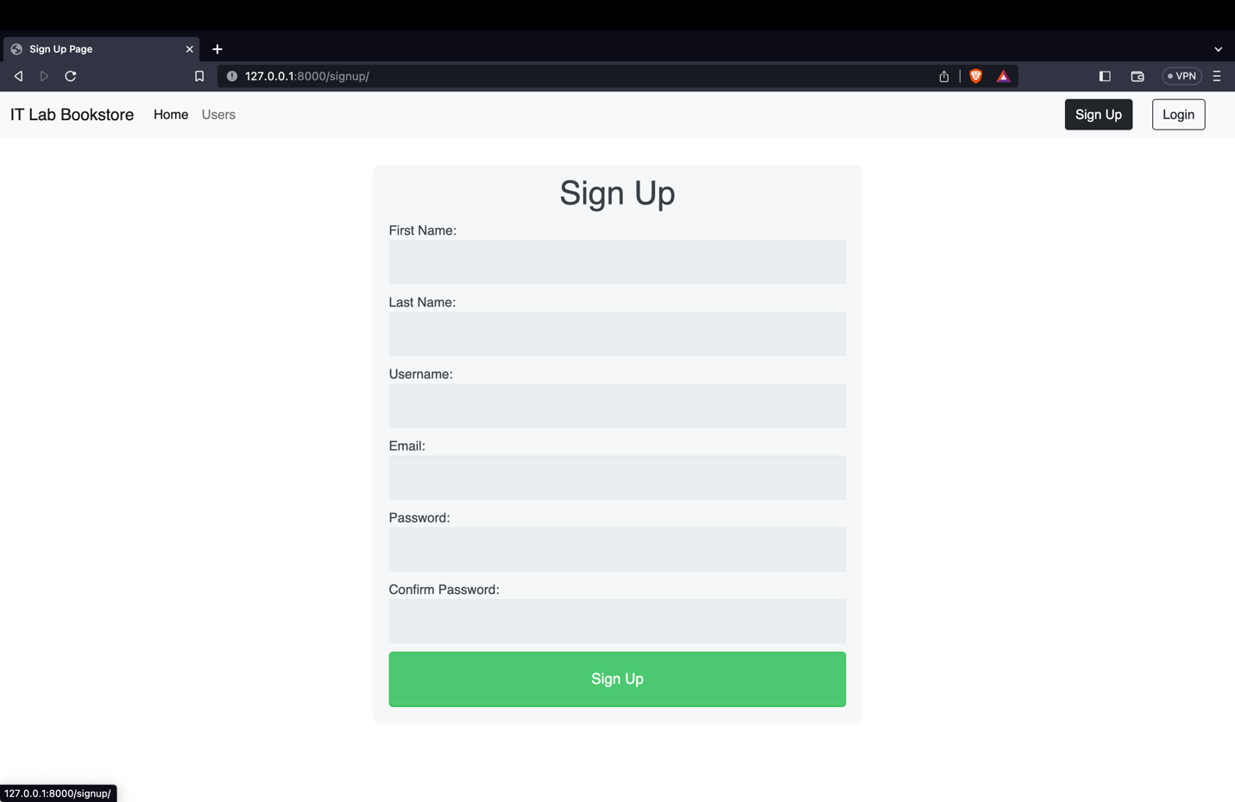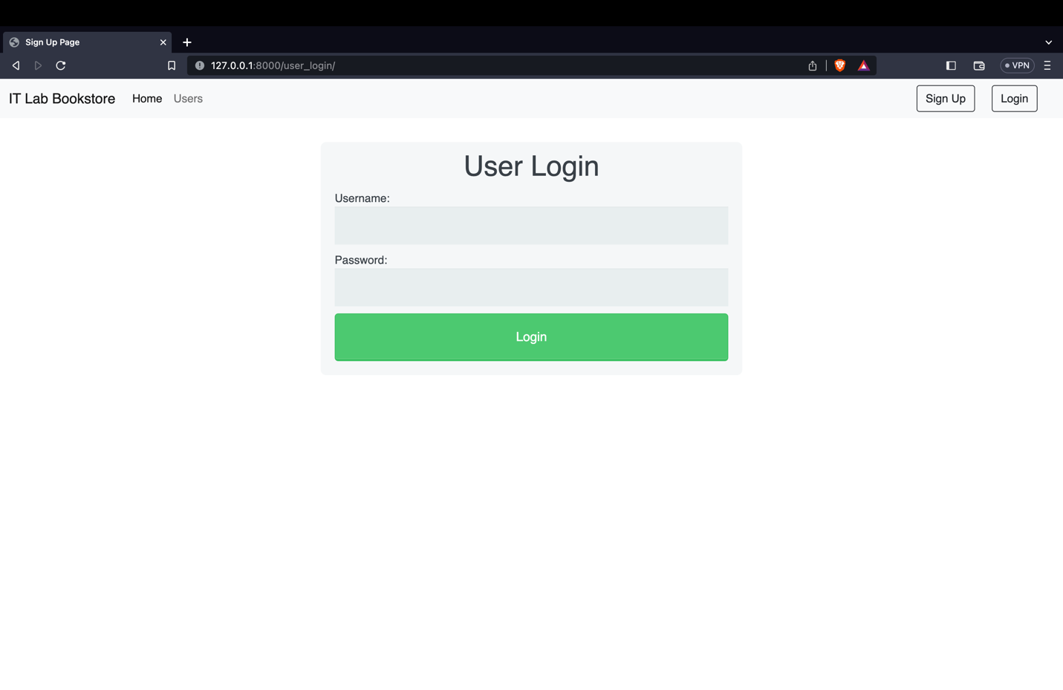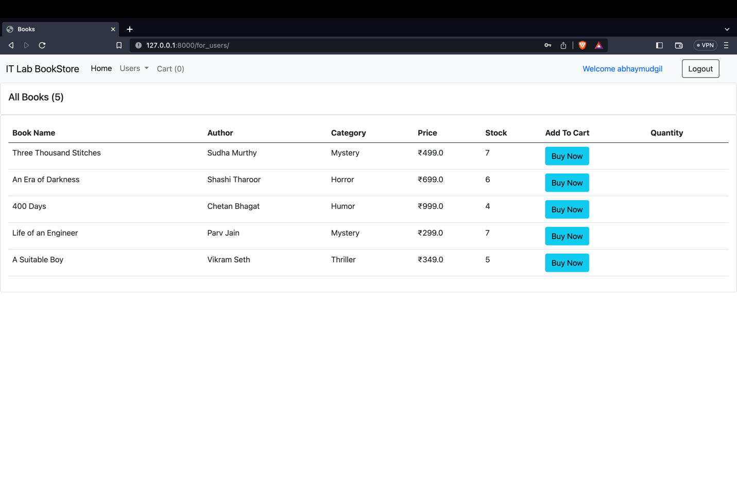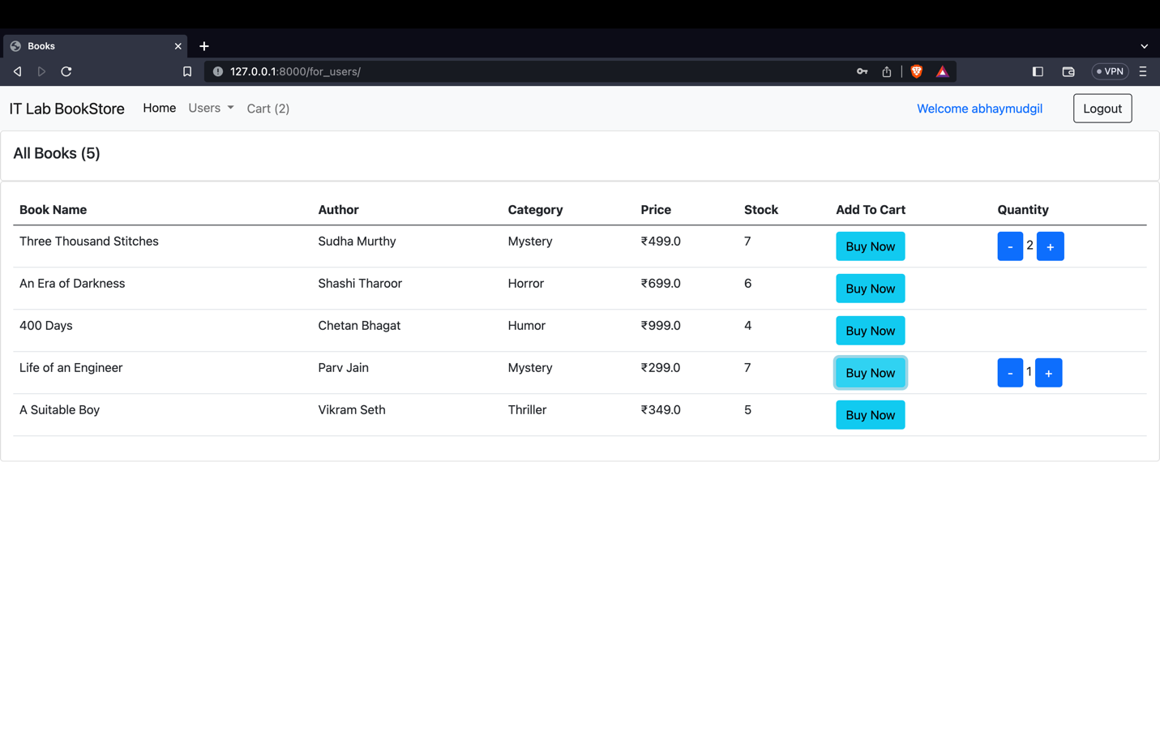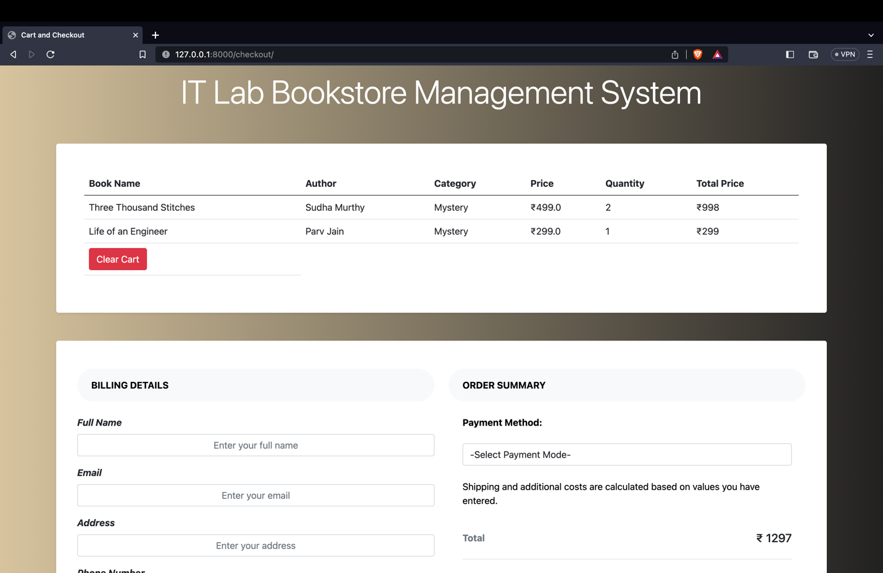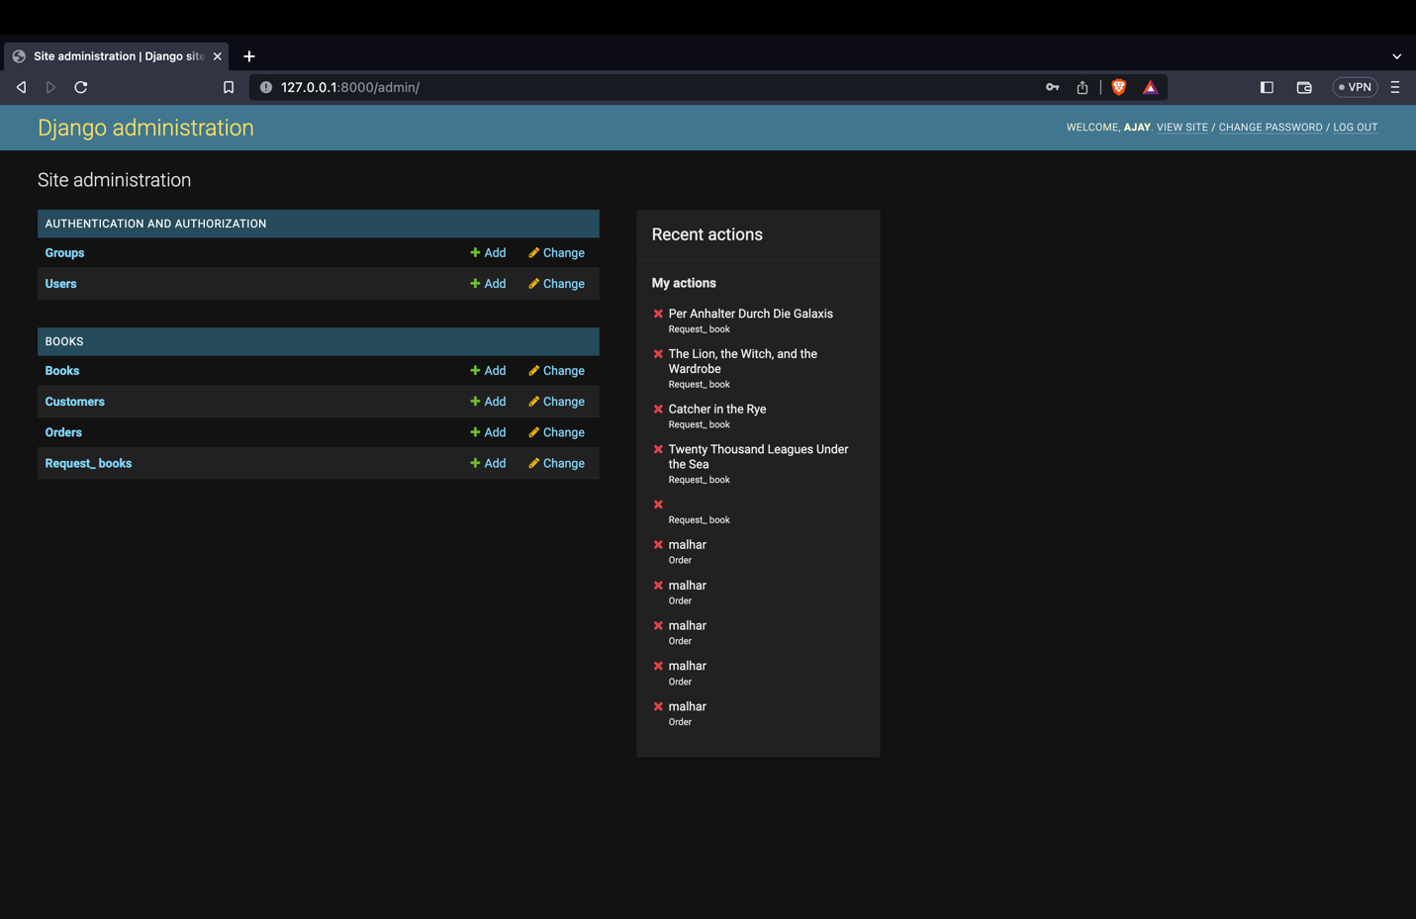

**CHAPTER 5: CONCLUSION**

In conclusion, the Bookstore Management System Django project serves as an excellent example of how modern web technologies can be used to streamline the bookstore process, improve the user experience, and enhance the online presence of bookstores. The project provides a comprehensive solution that automates stock management, order management, and payment integration, making it easier for customers to buy books and for bookstores to manage their operations efficiently. With its user-friendly interface, scalable architecture, and robust security features, the Bookstore Management System Django project is a practical and effective solution for any bookstore looking to expand their online presence and improve their service offerings. By implementing this project, bookstores can not only attract and retain more customers but also gain a competitive advantage in the market.

**CHATER 6: LIMITATIONS & FUTURE WORK**

Limitations:

* The current version of the Bookstore Management System Django project may not support certain advanced features such as real-time stock tracking or advanced analytics.
* The project may not be able to handle large volumes of data and may experience performance issues under heavy load.
* The project may not support multiple currencies or multiple languages, limiting its accessibility for customers in different regions.

Future Work:

* Integration of real-time stock tracking and monitoring features to enhance the user experience and improve operational efficiency.
* Integration of machine learning algorithms to optimize the pricing and availability of books.
* Development of a mobile application for the Bookstore Management System to enhance the accessibility and convenience of the system.
* Implementation of multi-currency and multi-language support to expand the system's accessibility to customers worldwide.

Overall, the Bookstore Management System Django project can be improved and expanded in various ways to provide a better service to both customers and bookstores. With the rapidly evolving nature of the book industry and the advancements in technology, continuous improvements and updates to the system are necessary to stay competitive and meet the changing needs of customers.

**CHAPTER 7: REFERENCES**

* <https://getbootstrap.com/docs/5.0/getting-started/introduction/>
* <https://www.w3schools.com/cssref/index.php>
* <https://docs.djangoproject.com/en/4.2/>
* <https://www.w3schools.com/html/html_intro.asp>